

CC-215-L: Database Systems Lab
Faculty of Computing & Information Technology

BS(CS&IT) Morning - Fall 2023
LAB – 08 (Assignment)
Task 01: [20 Marks]
In this Task, we’ll be using the tables you have already created in the previous lab.
- Insert records of 5 students in students table
INSERT INTO STUDENT (ROLLNO,FIRSTNAME,LASTNAME,CNIC,GENDER,PHONENO) VALUES (1,'ALI','KHAN',1234567890123,'M','03011234567');
INSERT INTO STUDENT (ROLLNO,FIRSTNAME,LASTNAME,CNIC,GENDER,PHONENO) VALUES (2,'AHMED','MALIK',1234567890124,'M','03011234568');
INSERT INTO STUDENT (ROLLNO,FIRSTNAME,LASTNAME,CNIC,GENDER,PHONENO) VALUES (3,'ABDULLAH','IKRAM',1234567890125,'M','03011234569');
INSERT INTO STUDENT (ROLLNO,FIRSTNAME,LASTNAME,CNIC,GENDER,PHONENO) VALUES (4,'FATIMA','ALI',1234567890126,'F','03011234560');
INSERT INTO STUDENT (ROLLNO,FIRSTNAME,LASTNAME,CNIC,GENDER,PHONENO) VALUES (5,'AYESHA','HASSAN',1234567890127,'F','03011234561');
RollNo | 1 | 2 | 3 | 4 | 5
FirstName | Ali | Ahmad | Abdullah | Fatima | Ayesha
LastName | Khan | Malik | Ikram | Ali | Hassan
CNIC | 1234567890123 | 1234567890124 | 1234567890125 | 1234567890126 | 1234567890127
Gender | M | M | M | F | F
PhoneNo | 03011234567 | 03011234568 | 03011234569 | 030112345670 | 03011234561

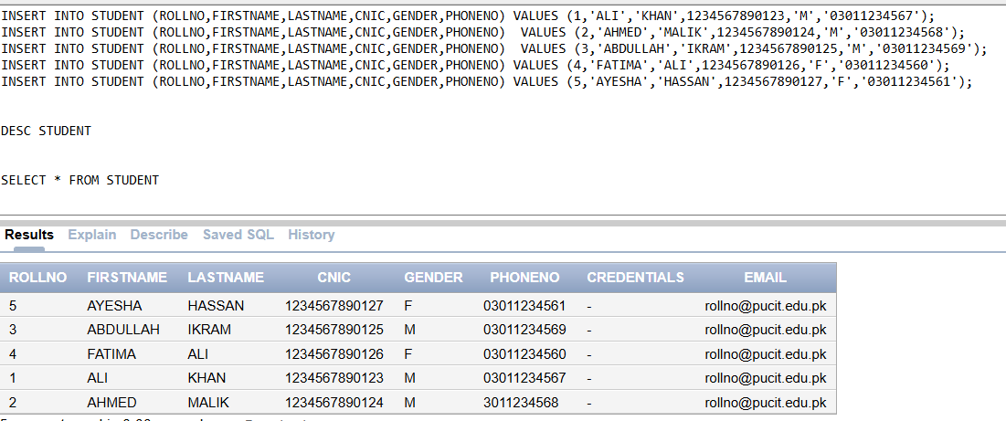
- Insert records of 4 Instructors in Instructor table
INSERT INTO INSTRUCTOR (REGNO,FIRSTNAME,QUALIFICATION,JOINING) VALUES (1,'DR.ASIF SOHAIL','PhD IN Computer Science',SYSDATE);
INSERT INTO INSTRUCTOR (REGNO,FIRSTNAME,QUALIFICATION,JOINING) VALUES (2,'DR.SOBIA','PhD IN Mathematics',SYSDATE);
INSERT INTO INSTRUCTOR (REGNO,FIRSTNAME,QUALIFICATION,JOINING) VALUES (3,'DR.IMRAN','PhD IN IT',SYSDATE);
INSERT INTO INSTRUCTOR (REGNO,FIRSTNAME,QUALIFICATION,JOINING) VALUES (4,'DR.AYESHA','PhD IN SE',SYSDATE);
RegNo | 1 | 2 | 3 | 4
FirstName | Dr. Asif Sohail | Dr. Sobia | Dr. Imran | Dr. Ayesha
Qualification | PhD in Computer Science | PhD in Mathematics | PhD in IT | PhD in SE
JoiningDate | Sysdate | Sysdate | Sysdate | Sysdate

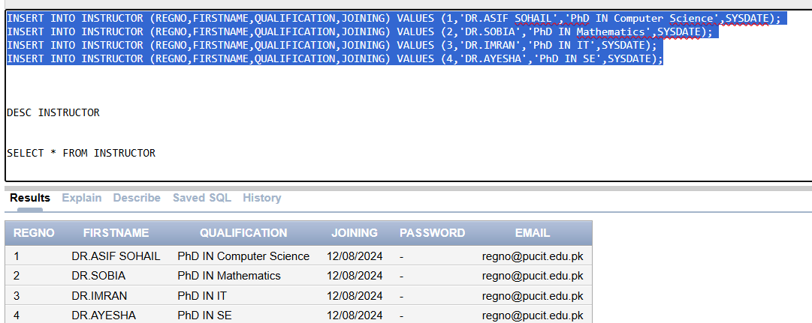
- Insert 4 Courses in Course Table
INSERT INTO COURSE VALUES ('CS101','PROGRAMMING FUNDAMENTALS',4,NULL);
INSERT INTO COURSE VALUES ('CS102','OBJECT ORIENTED PROGRAMMING',3,'CS101');
INSERT INTO COURSE VALUES ('CS103','DATA STRUCTURES',2,'CS102');
INSERT INTO COURSE VALUES ('CS104','DATABASE SYSTEMS',1,NULL);
CourseCode | CS101 | CS102 | CS102 | CS102
CourseTitle | Programming Fundamentals | Object Oriented Programming | Data-structures | Database Systems
InstructorID | 4 | 3 | 2 | 1
PreRequisite | null | CS101 | CS102 | null

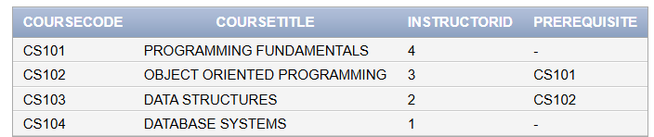
- Enroll at least 2 students in each course.
INSERT INTO ENROLLMENT (STUDENTID,COURSECODE) VALUES(1,'CS101');
INSERT INTO ENROLLMENT (STUDENTID,COURSECODE) VALUES(2,'CS101');
INSERT INTO ENROLLMENT (STUDENTID,COURSECODE) VALUES(3,'CS102');
INSERT INTO ENROLLMENT (STUDENTID,COURSECODE) VALUES(4,'CS102');
INSERT INTO ENROLLMENT (STUDENTID,COURSECODE) VALUES(5,'CS103');
INSERT INTO ENROLLMENT (STUDENTID,COURSECODE) VALUES(4,'CS103');
INSERT INTO ENROLLMENT (STUDENTID,COURSECODE) VALUES(5,'CS104');
INSERT INTO ENROLLMENT (STUDENTID,COURSECODE) VALUES(4,'CS104');
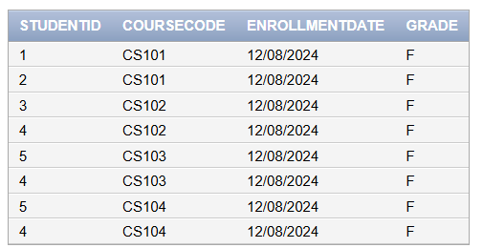
- Mark attendance of all the students in all courses for current date.
INSERT INTO ATTENDANCE
SELECT STUDENTID,COURSECODE,SYSDATE,'P'
FROM ENROLLMENT ;
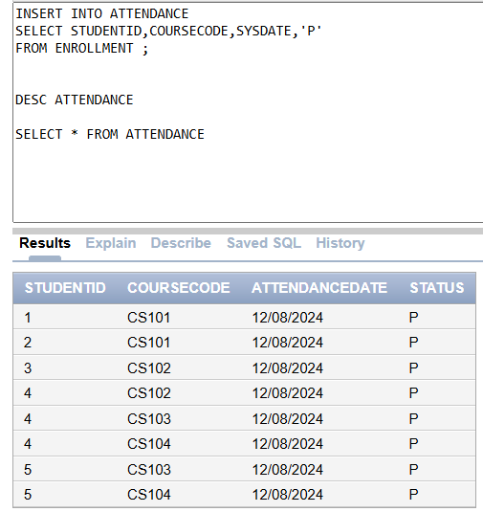
- Insert your record and enroll yourself in the Course Database systems and mark your attendance as well.
INSERT INTO STUDENT VALUES('BITF23M017','Zohaib','Haider','34501-2354875-2','M','03279900323','1122','zh442005@gmail.com');

INSERT INTO ENROLLMENT VALUES('BITF23M017','CS104',SYSDATE,NULL);

INSERT INTO ATTENDANCE
SELECT STUDENTID,COURSECODE,SYSDATE,'P'
FROM ENROLLMENT
WHERE STUDENTID = 'BITF23M017';
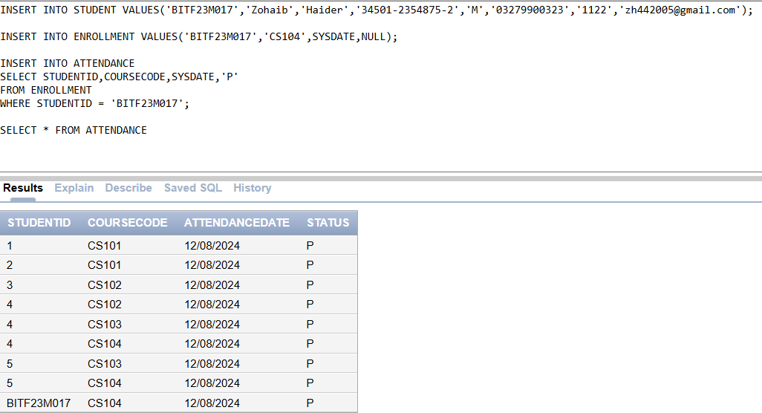
- Update your phone number in the students table.
UPDATE STUDENT
SET PHONENO = '03279900323'
WHERE ROLLNO = 'BITF23M017';
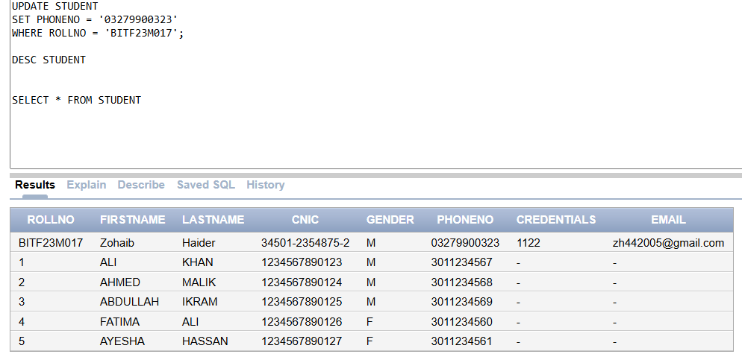
- Delete any student record from the students table.
DELETE FROM STUDENT
WHERE ROLLNO = '2';
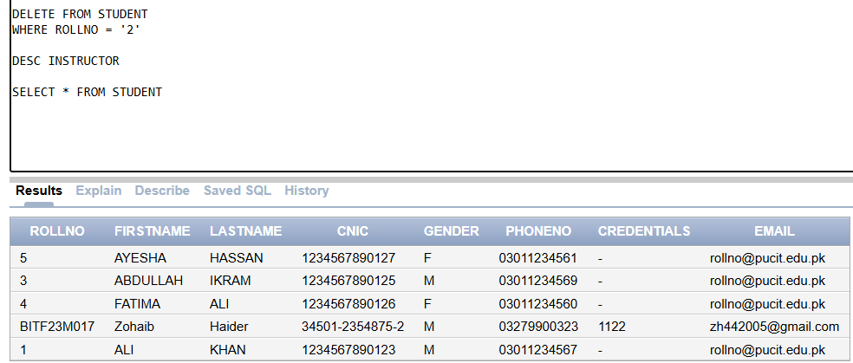
- Update the joining date of any instructor.
UPDATE INSTRUCTOR
SET JOINING = TO_DATE('12/02/2024','DD/MM/YYYY')
WHERE REGNO = 4;
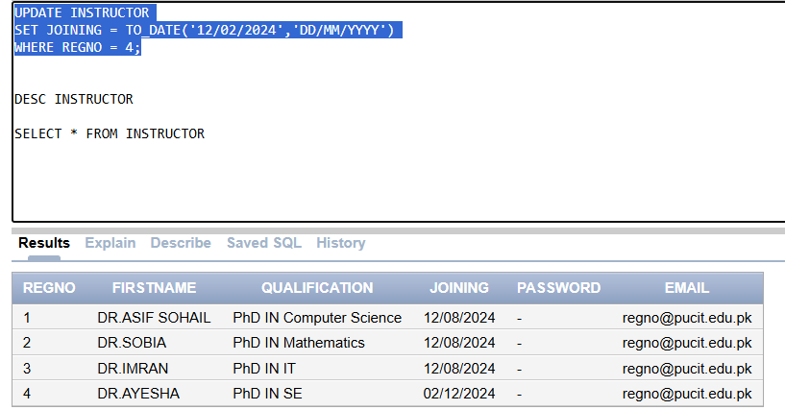
- Update your grade in Database systems to ‘A’.
UPDATE ENROLLMENT
SET GRADE = 'A'
WHERE STUDENTID = 'BITF23M017';
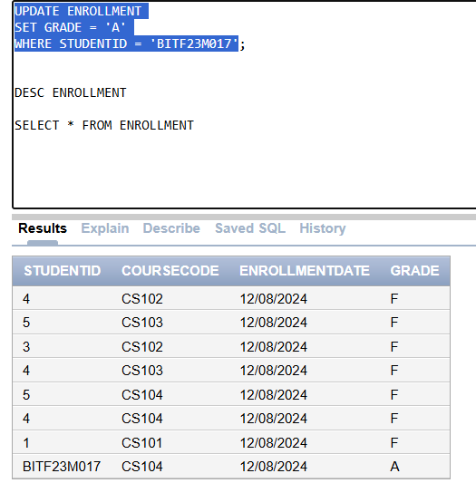
Note: After inserting, Updating and deleting records you have to show the resulting tables.

Task 02: [20 Marks]
- Create a view that shows each employee's name, job, salary, and department name, but only for employees in the 'SALES' department and earning more than 2500.

CREATE VIEW SALES_DEPT

AS SELECT ENAME,JOB,SAL,DNAME

FROM EMP E

JOIN DEPT D

ON E.DEPTNO = D.DEPTNO

WHERE DNAME LIKE '%SALES' AND SAL > 2500;

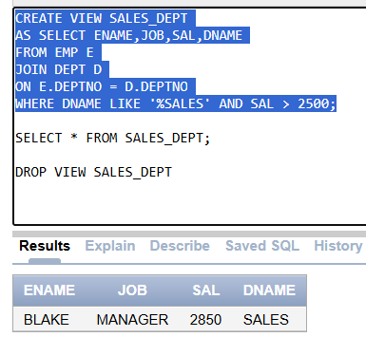
- Create a view for employees in ‘SALES’ or ‘RESEARCH’, ensuring updates restrict employees to these departments.

CREATE VIEW SALES_RESEARCH

AS SELECT EMPNO,ENAME,JOB,COMM,MGR,HIREDATE,SAL,E.DEPTNO

FROM EMP E

JOIN DEPT D

ON E.DEPTNO = D.DEPTNO

WHERE DNAME LIKE 'SALES%' OR DNAME LIKE 'RESE%'

WITH CHECK OPTION;

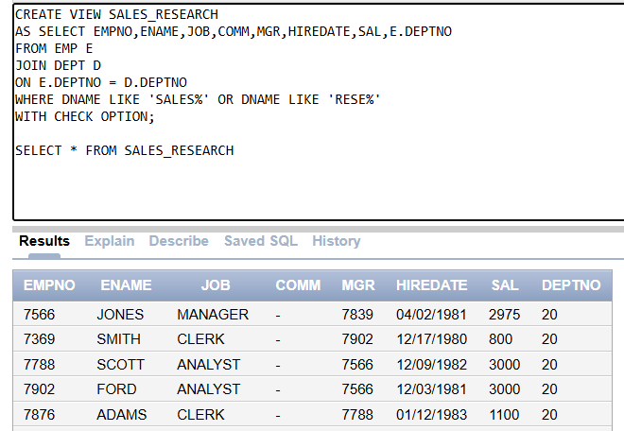
- Create a view showing employees and their managers, only for employees in the ‘RESEARCH’ department, including the manager's department.

CREATE VIEW EMP_MGR AS

SELECT E.ENAME EMP, E.MGR MANAGER, D.DNAME DEPT, D2.DNAME MGR_DEPT

FROM EMP M

JOIN EMP E

ON M.EMPNO = E.MGR

JOIN DEPT D

ON E.DEPTNO = D.DEPTNO

JOIN DEPT D2

ON M.DEPTNO = D2.DEPTNO

WHERE D.DNAME LIKE 'RES%';

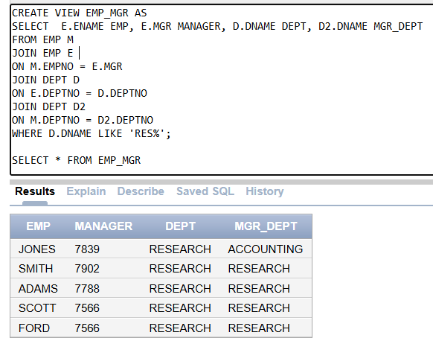
- Create a view that shows each department’s name, location, and average salary for departments with an average salary greater than 2500, excluding employees without a manager.

CREATE VIEW NOCOMM_SALES_DEPT

AS SELECT EMPNO, ENAME, JOB, COMM, MGR, HIREDATE, SAL, DEPTNO

FROM EMP NATURAL JOIN DEPT

WHERE DNAME LIKE 'SALE%' AND (COMM IS NULL OR COMM = 0);

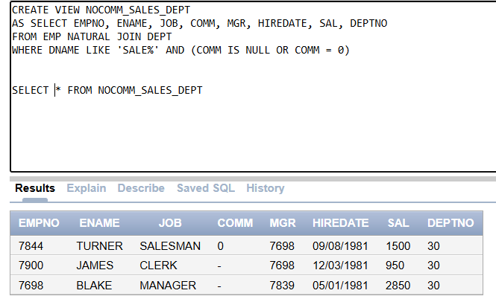
- Create a view for employees in the 'SALES' department who do not receive commission.

CREATE VIEW SALE_DEPTM AS

SELECT *

FROM EMP

NATURAL JOIN DEPT

WHERE (COMM IS NULL OR COMM = 0) AND DNAME LIKE 'SAL%';

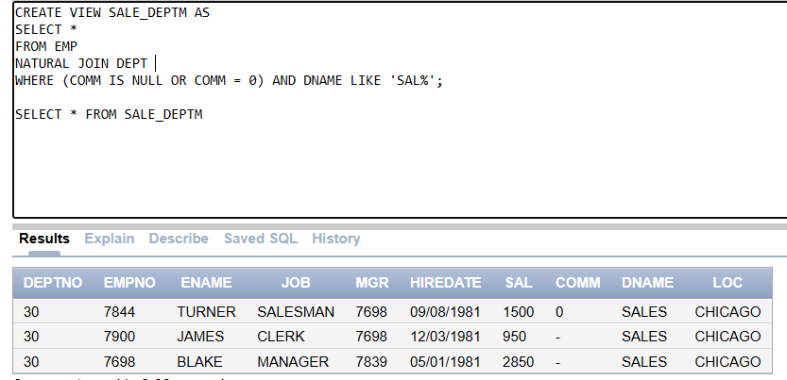
- Create a view showing employees earning more than 3000 along with their department name and location, and a column for their salary-to-average-salary ratio.
CREATE VIEW EMP_SAL AS
SELECT ENAME,DNAME,LOC, ROUND(SAL/(SELECT AVG(SAL) FROM EMP)) AS SAL_RATIO
FROM EMP E
JOIN DEPT D
ON E.DEPTNO = D.DEPTNO
WHERE SAL > 3000;
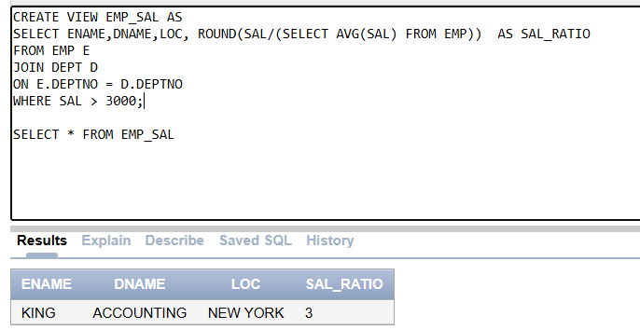
- Create a view listing employees hired before 1981 in the ‘ACCOUNTING’ department, showing their name, job, hire date, and years of service.
CREATE VIEW EMP_HIRED AS
SELECT ENAME,JOB,HIREDATE,ROUND(SYSDATE - HIREDATE)/365 SERVICE_YEARS
FROM EMP NATURAL
JOIN DEPT
WHERE EXTRACT(YEAR FROM HIREDATE) < 1981 AND DNAME LIKE 'ACCOUNTING%';
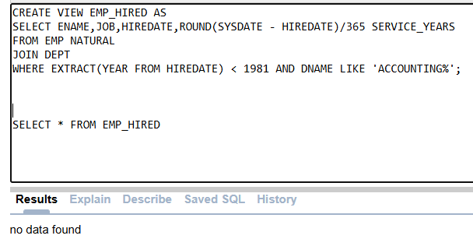
- Create a view showing department name, location, and the number of employees in each department, only for departments with more than 3 employees.
CREATE VIEW EMP_COUNT AS
SELECT DNAME,LOC,COUNT(EMPNO) NUM_EMP
FROM EMP E
JOIN DEPT D
ON E.DEPTNO = D.DEPTNO
GROUP BY DNAME,LOC
HAVING COUNT(EMPNO) > 3;
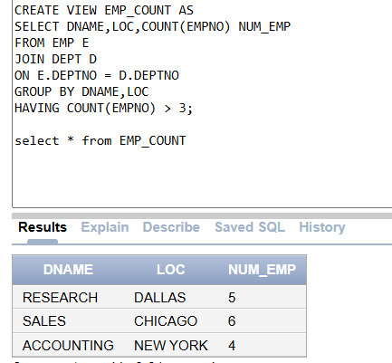
- Create a view allowing updates to employee records only for employees in the ‘ACCOUNTING’ department.
CREATE VIEW UPDATE_EMP AS
SELECT *
FROM EMP
NATURAL JOIN DEPT
WHERE DNAME LIKE 'ACCOU%'
WITH CHECK OPTION;
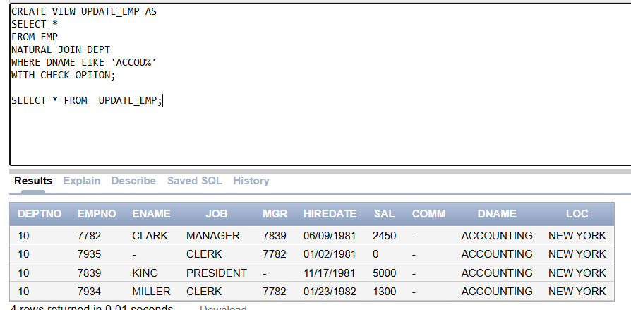
- Name the views in which values can be inserted. If not, Come up with a valid reason.
THAT ALLOW IINSERTION:
- UPDATE_EMP
- SALES_RESEARCH
THAT DON’T ALLOW INSERTION:
- SALES_DEPT (FILTERING ON SAL)
- EMP_MGR (COMPLEX JOINS)
- NOCOMM_SALES_DEPT (FILTERING BASED ON COMM STATUS)
- SALE_DEPTM (FILTERING BASED ON COMM STATUS)
- EMP_SAL (COMPUTED SAL-TO-AVG-SAL RATIO)
- EMP_HIRED (COMPUTED SERVICE YEARS)
- EMP_COUNT (AGG EMP COUNT)

